Committed to delivering a safe environment

www.safegolf.org
for golf

Is something worrying you?
Do you need someone to talk to? Speak to your club welfare officer
Telephone 01274 831215

Name Richard Parker Miller

Email
richard@headleyvenue.co.uk/

Co
ABOUT ME
I joined Headley as General Manager 1st March 2018 and my role is to build Headley into West Yorkshires premier venue and golf club .
I have over 30 years experience in hospitality and look forward to working with all the members to ensure Headley grows and expands its membership .

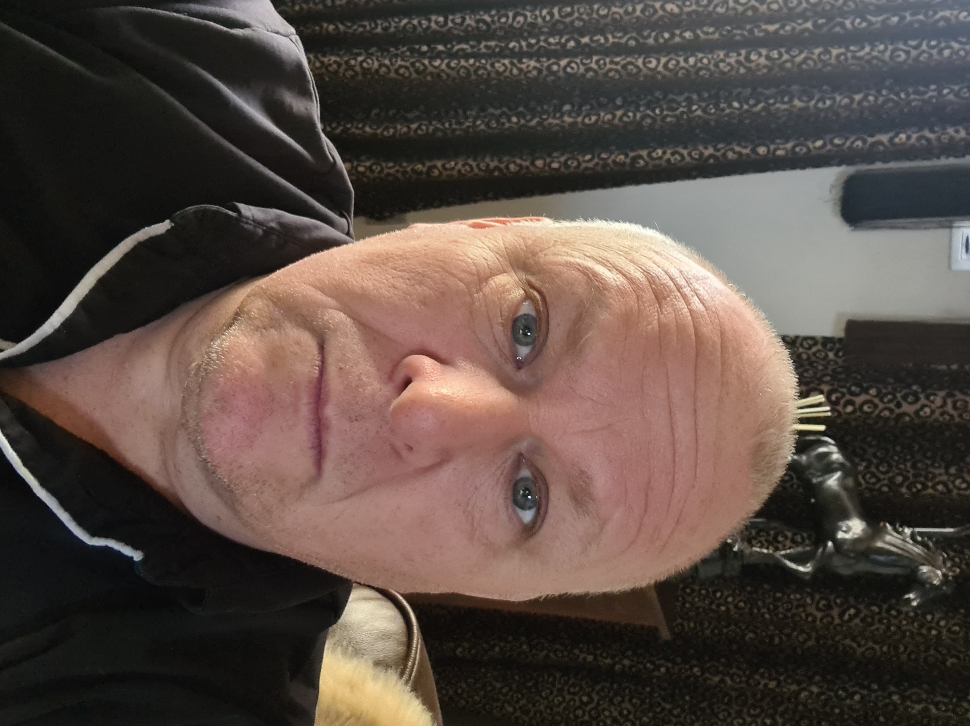

Alternatively, you can speak to someone at

ChildLine 0800 1111
NSPCC 0808 800 5000
England Golf 01526 351851

Club
WELFARE
officer

